**NFT Marketplace Using Blockchain Technology**

**Prepared by**

**Arpan Basu 201220100110018**

**Sayak Karui 201220100110039**

**Soumyak Mitra University Registration No.**

**Anubhav Routh 211220100120001**

**Under the guidance of**

**Amartya Chakraborty**

**Assistant Professor**

**Project Report**

**Submitted in the partial fulfillment of the requirement for the degree of**

**B.Tech in Computer Science and Engineering**

**Department of Computer Science and Engineering**

**St. Thomas’ College of Engineering and Technology**

**Affiliated to**

**Maulana Abul Kalam Azad University of Technology, West Bengal**

**May, 2024**

**St. Thomas’ College of Engineering and Technology**

**Department of Computer Science and Engineering**

This is to certify that the work in preparing the project entitled NFT Marketplace Using Blockchain Technology has been carried out by **Arpan Basu, Sayak Karui, Soumyak Mitra, Anubhav Routh** under my guidance during the session 2023-24 and accepted in the partial fulfillment of the requirement for the degree of Bachelor of Technology in Computer Science and Engineering.

**Signature Signature**

**Amartya Chakraborty Dr. Mousumi Dutt**

**Assistant Professor Head of the Department**

**Department of Computer Science Department of Computer Science**

**and Engineering and Engineering**

**St. Thomas’ College of Engineering St. Thomas’ College of Engineering**

**and Technology and Technology**

**St. Thomas’ College of Engineering and Technology**

**Department of Computer Science and Engineering**

**Acknowledgement**

The success and final outcome of this project required a lot of guidance and assistance from many people and we are extremely privileged to have got this all along the completion of our project. All that we have done is only due to such supervision and assistance and we would not forget to thank them. We respect and thank Amartya Chakraborty, Assistant Professor, Dr. Uddalak Chatterjee, Assistant Professor, for providing us an opportunity to do the project work and giving us all support and guidance, which made us complete the project duly. We are extremely thankful to him for providing such nice support and guidance, although he had a busy schedule managing the corporate affairs. We owe our deep gratitude to our project mentor Amartya Chakraborty, Assistant Professor, Dr. Uddalak Chatterjee, Assistant Professor, who took keen interest in our project work and guided us all along, till the completion of our project work by providing all the necessary information for developing a good system. We heartily thank our internal project mentor, Amartya Chakraborty, Assistant Professor, Dr. Uddalak Chatterjee, Assistant Professor, Computer Science & Engineering, for him guidance and suggestions during this project work. We are thankful to and fortunate enough to get constant encouragement, support and guidance from all Teaching staff of Computer Science & Engineering which helped us in successfully completing our project work. Also, we would like to extend our sincere esteems to all staff in the laboratory for their timely support.

**Signature with date Signature with date**

**Arpan Basu, 12200120044 Sayak Karui, 12200120023**

**Signature with date Signature with date**

**Soumyak Mitra, 12200121065 Anubhav Routh, 12200121062**

**St. Thomas’ College of Engineering and Technology**

**Department of Computer Science and Engineering**

**Declaration**

We declare that this written submission represents our ideas in our own words and we have adequately cited and referenced the original sources. We also declare that we have adhered to all the principles of academic honesty and integrity and have not misrepresented or fabricated or falsified any idea/data/fact/source in our submission. We understand that any violation of the above will be cause for disciplinary action by the Institute and can also evoke penal action from the sources which have thus not been properly cited or from whom proper permission has not been taken when needed.

**Signature Signature**

**Arpan Basu Sayak Karui**

**Roll No.:** **12200120044 Roll No.:** **12200120023**

**Signature Signature**

**Soumyak Mitra Anubhav Routh**

**Roll No.:** **12200121065 Roll No.:** **12200121065**

**Index**

I. Pre-amble

I.I Institute Vision and Mission

Department Vision and Mission i

I. II Program Outcome (PO) and Program Specific Outcome (PSO) ii

I. III PO and PSO mapping with justification iii

Chapter 1

Introduction

1.1 Objective of the Project………………………………

1.2 Brief description of Project…………………………………………………

1.3 Tools & Platform……………………………………………………………

1.4 Project Organization………………………………………………………...

1.5 Project Timeline……………………………………………………………..

Chapter 2

Literature Survey……………………………………………………………………

Chapter 3

Concepts and Problem Analysis

…………………………………………………………..

Chapter 4

Design & Methodology

…………………………………………………………..

Chapter 5

Sample Codes (if any)

…………………………………………………………..

Chapter 6

Testing, Results, Discussion on Results

…………………………………………………………..

Chapter 7

Conclusion and Future Work

…………………………………………………………..

Bibliography ………………………………………………………………………

**I. Pre-amble**

An NFT Marketplace is an online platform facilitating the buying, selling, and trading of unique digital assets known as non-fungible tokens (NFTs), enabling creators to showcase, auction, and monetize their digital art, collectibles, music, and more within a decentralized ecosystem.

**I.I Vision and Mission of the Institute:**

The Institute's vision for the NFT Marketplace project is to pioneer a cutting-edge platform that fosters inclusivity, innovation, and transparency in the digital asset space. Its mission is to empower creators worldwide by providing a secure, user-friendly marketplace that facilitates the creation, discovery, and exchange of unique digital assets while fostering a community-driven environment that values creativity and authenticity.

**Vision of the Institute:**

To continually improve upon its teaching-learning process and research with a goal to develop technical manpower with the sound academic backgrounds, who will respond to challenges and changes faced by dynamic scenario of Computer science and technology.

**Mission of the Institute:**

To enhance the quality of Engineering education and delivery through accessible, comprehensive and research-oriented teaching-learning-assessment processes in the state-of-art environment. To create opportunities for students and faculty members to acquire professional knowledge and develop managerial, entrepreneurial and social attitudes with highly ethical and moral values. To satisfy the ever-changing needs of the nation with respect to evolution and absorption of sustainable and environment friendly technologies for effective creation of knowledge-based society in the global era.

**Vision and Mission of the Department:**

To continually improve upon its teaching-learning process and research with a goal to develop technical manpower with the sound academic backgrounds, who will respond to challenges and changes faced by dynamic scenario of Computer science and technology.

**Vision of Computer Science and Engineering Department:**

The CSE Department aims to explore blockchain's intersection with digital creativity through the NFT Marketplace, fostering innovation and interdisciplinary collaboration.

**Mission of Computer Science and Engineering Department:**

1. To inspire the students to work with latest tools and to make them industry ready.
2. To impart research based technical knowledge
3. To groom the department as a learning centre to inculcate advancement of technology in Computer Science and Engineering with social and environmental awareness.

**I. II Program Outcome (PO) and Program specific Outcome (PSO)**

**Program Outcome (PO):**

The project aims to yield tangible outcomes such as a functional NFT Marketplace prototype, fostering interdisciplinary collaboration, advancing blockchain integration in digital creativity, and cultivating a platform for innovative digital asset exchange.

**Engineering Graduates will be able to:**

1. **Engineering Knowledge**: Apply the knowledge of mathematics, science, engineering fundamentals and an engineering specialization to the solution of complex engineering problems.
2. **Problem analysis**: Identify, formulate, review research literature, and analyze complex engineering problems reaching substantiated conclusions using first principles of mathematics, natural science, and engineering sciences.
3. **Design/Development of solutions**: space design solutions for complex engineering problems and design system components or process that meet the specified needs with appropriate consideration for the public health and safety and the culture societal and environmental considerations.
4. **Conduct investigations of complex problems**: Search based knowledge and research methods including design of experiments, analysis and interpretation of data and synthesis of the information to provide valid conclusion.
5. **Modern tool usage**: Create, select, and apply appropriate techniques, resources and modern engineering and it tools including prediction and modeling to complex engineering activities with an understanding of the limitations.
6. **The engineer and society**: Apply reasoning informed by the contextual knowledge to assess societal, health, safety, legal and cultural issues and the consequent responsibilities relevant to the professional engineering practice.
7. **Environment and sustainability**: Understand the impact of professional engineering solutions in society and environmental contexts and demonstrate the knowledge of an need for sustainable development.
8. **Ethics**: Apply ethical principles and commit to professional ethics and responsibilities and norms of the engineering practice.
9. **Individual and teamwork**: Function effectively as an individual, and as a member or leader in diverse teams and in multi-disciplinary settings.
10. **Communication**: Communicate effectively on complex engineering activities with the engineering community and with society at large, such as being able to comprehend and write effective reports and design documentation make effective presentations, and give and receive clear instructions.
11. **Project management and finance**: Demonstrate knowledge and understanding of the engineering and management principles and apply this to one’s own work as a member and leader in a team to manage projects and in multidisciplinary environment.
12. **Lifelong learning**: Recognize the need for and have the preparation and ability to engage in independent and lifelong learning in the broadest context of technological change.

**Program Educational Objectives of Computer Science and Engineering (PEOs): It may vary depending on the specific program, institution, and their respective emphasis on certain aspects of computer science and engineering education.**

**Graduates of computer science and engineering program shall**

* + Have skills to solve the problem by analysis, design, develop and implementation of algorithms leading to optimal solutions fulfilling the dynamic requirement of industry and society.
  + Have good understanding of computer science and engineering concepts, making them practicing engineers with sound knowledge of logic and design in industries.
  + Undertake research in emerging fields in computer science and engineering so as to face the challenges of global challenges in their higher studies and by lifelong learning.

## Program specific Outcome (PSO):

PSO1: Programming skills: Apply fundamental knowledge and programming aptitude to identify designed and solve real life problems.

PSO2: Professional skills: Students shall understand, analyze and develop software solutions to meet the requirements of industry and society. Deadline

PSO3: Competency: Students will be competent for competitive examinations for employment, higher studies and research.

**I.III PO and PSO mapping with justification**

|  |  |  |  |  |  |  |  |  |  |  |  |  |  |  |  |
| --- | --- | --- | --- | --- | --- | --- | --- | --- | --- | --- | --- | --- | --- | --- | --- |
|  | PO1 | PO2 | PO3 | PO4 | PO5 | PO6 | PO7 | PO8 | PO9 | PO  10 | PO  11 | PO  12 | PSO  1 | PSO  2 | PSO  3 |
| NFT  Marketplace using Blockchain Technology | - | 2 | 3 | 2 | 3 | 1 | - | 2 | 3 | 2 | - | 3 | 3 | 2 | - |

## Justification:

1. **PO2 - 2:** Analyze and address complex problems within blockchain implementation for the NFT marketplace.
2. **PO3 - 3:** Design solutions for the NFT marketplace, considering societal, environmental, and functional needs.
3. **PO4 - 2:** Employ research methods in blockchain context but needs enhancement in synthesizing blockchain-specific information.
4. **PO5 - 3:** Utilize modern tools and techniques for prediction and modeling within blockchain technology.
5. **PO6 - 1:** Limited alignment; more emphasis on societal implications of blockchain might be beneficial.
6. **PO8 - 2:** Consider ethical responsibilities in engineering practice, but with more focus on blockchain ethics.
7. **PO9 - 3:** Engage effectively in multi-disciplinary teamwork crucial for developing the NFT marketplace.
8. **PO10 - 2:** Communicate project-related information effectively within the engineering community, with potential for more blockchain-specific emphasis.
9. **PO12 - 3:** Demonstrate continuous learning and adaptability in the rapidly evolving landscape of blockchain technology for NFTs.
10. **PSO1 - 3**: Aligns well as the project requires applying programming skills to design and solve real-life problems, essential for implementing blockchain solutions in the NFT marketplace.
11. **PSO2 - 2**: Partial alignment as the project involves developing software solutions for societal needs, but additional emphasis on industry-specific requirements related to blockchain might enhance alignment

**Chapter 1: Introduction**

Exploring the intersection of blockchain technology and digital creativity through a pioneering NFT marketplace.

**1.1 Objective of the Project:**

In developing this system, some project objectives had been specified. The main purpose of this project is to set the foundation for a comprehensive NFT marketplace project that not only focuses on technological aspects but also considers user experience, governance, compliance, and sustainability to create a holistic and successful platform.

* **Develop a Robust Platform**: Create a user-friendly and secure NFT marketplace built on blockchain technology, ensuring robustness, reliability, and scalability.
* **Implement Blockchain Integration**: Integrate blockchain protocols (such as Ethereum, Binance Smart Chain, or others) to authenticate, mint, and trade NFTs while ensuring interoperability.
* **Enhance Security Measures**: Implement advanced security measures, including encryption, multi-factor authentication, and smart contract audits to safeguard user assets and transactions.
* **Optimize User Experience**: Focus on a seamless user interface and experience to attract and retain users, catering to both creators and collectors within the NFT ecosystem.
* **Establish Governance Framework**: Design and implement a governance model that enables community involvement in decision-making processes and platform evolution.
* **Ensure Regulatory Compliance**: Navigate legal and regulatory requirements related to NFTs, digital assets, and intellectual property rights to ensure compliance and mitigate risks.
* **Facilitate Asset Tokenization**: Enable the tokenization of various digital and real-world assets, allowing creators to tokenize their content and users to trade diverse NFTs.
* **Promote Sustainability**: Explore and implement eco-friendly blockchain solutions or contribute to sustainability initiatives to reduce the environmental impact of the platform.
* **Drive Adoption and Engagement**: Develop strategies to promote the marketplace, engage creators, collectors, and users, fostering adoption and active participation.
* **Provide Educational Resources**: Offer educational resources and guides on NFTs, blockchain, and the marketplace, aiming to increase awareness and understanding among users.
* **Measure and Optimize Performance**: Establish metrics and analytics to track platform performance, user engagement, and transaction volumes, aiming for continuous improvements.

**1.2 Brief Description of the Project:**

Creating an innovative NFT marketplace, merging art with technology, while tackling scalability and regulatory challenges for a sustainable digital ecosystem

The project aims to develop a cutting-edge decentralized Non-Fungible Token (NFT) marketplace powered by blockchain technology. This marketplace will serve as a secure, transparent, and user-centric platform for creators, collectors, and enthusiasts to trade, mint, and manage NFTs seamlessly.

**Key Features:**

These are the major key features related to the project -

* **Blockchain Integration**: Leveraging blockchain protocols like Ethereum, Binance Smart Chain, or compatible networks to ensure secure transactions, ownership verification, and asset tokenization.
* **User-Friendly Interface**: Designing an intuitive and accessible interface for creators to mint NFTs easily and for collectors to browse, buy, and manage their digital assets effortlessly.
* **Smart Contract Implementation**: Implementing smart contracts to automate transactions, enforce agreements, and ensure transparency in all NFT-related activities.
* **Robust Security Measures**: Employing advanced security protocols, encryption methods, and regular audits to protect user assets, data, and transactions from potential threats.
* **Community Engagement**: Establishing a governance framework that fosters community participation in decision-making processes and platform evolution.
* **Regulatory Compliance**: Addressing legal and regulatory requirements concerning digital assets, copyrights, and ownership rights to ensure compliance and mitigate risks.
* **Environmental Sustainability**: Exploring and implementing eco-friendly blockchain solutions or contributing to sustainability initiatives to minimize the environmental impact of the platform.

**1.3 Tools and Platform:**

In the development of a decentralized NFT marketplace using blockchain technology, several tools and platforms play crucial roles in different phases of the project. Here are some key ones:

* **Blockchain Protocols:** Depending on the chosen blockchain network (Ethereum, Binance Smart Chain, Flow, etc.), the specific protocol will be utilized to create, store, and manage NFTs. Ethereum, with its robust smart contract functionality, is widely used for NFT development.
* **Smart Contract Development:** Tools like Solidity (programming language for Ethereum), Truffle, and Remix IDE facilitate the creation, testing, and deployment of smart contracts defining NFT standards (ERC-721, ERC-1155).
* **NFT Standards and Libraries:** OpenZeppelin provides secure and community-audited libraries for creating ERC-721 and ERC-1155 compliat contracts, aiding in standardized NFT development.
* **Web3.js and Ethers.js:** These JavaScript libraries enable interaction with the blockchain, allowing the frontend of the NFT marketplace to communicate with the blockchain network, perform transactions, and retrieve data.
* **IPFS (InterPlanetary File System):** For storing and retrieving decentralized, immutable content associated with NFTs, IPFS is often used. It provides a decentralized file storage system that integrates well with blockchain.
* **Wallet Integrations:** Integration with popular cryptocurrency wallets like MetaMask or Trust Wallet enables users to interact securely with the NFT marketplace, sign transactions, and manage their digital assets.
* **Frontend Development Frameworks:** Frameworks like React, Vue.js, or Angular might be utilized for building the frontend interface of the marketplace, ensuring a smooth user experience.
* **Testing and Deployment Platforms:** Tools like Ganache for local blockchain development, Infura for Ethereum node access, and services like Git for version control.
* **Analytics and Monitoring Tools:** Services like Etherscan or similar blockchain explorers allow for monitoring transactions, tracking NFTs, and providing insights into blockchain activity.
* **Security Auditing Services:** External auditing firms or platforms specialized in smart contract security audits, such as Certik or OpenZeppelin, can be employed to ensure the security of smart contracts and the overall platform.

**1.4 Project Organization:**

The basic workflow of our project is given below:

**Smart Contract Development**

(Using Solidity programming language with tools like Truffle and Remix IDE to develop smart contracts for the NFT marketplace.)

**Blockchain Protocols & NFT Standards and Libraries**

(Utilizing Open Zeppelin for NFT standards and libraries using Blockchain Protocol.)

**Frontend Development**

(Employing React, Vue.js, or Angular for building the user interface of the marketplace and integrating these libraries for interaction with the Ethereum blockchain.)

**IPFS Wallet Integrations**

(Storing NFT data on the Interplanetary File System for decentralized and efficient file storage and Adding support for MetaMask, Trust Wallet, or other popular wallets for users to access the marketplace.)

**Testing and Deployment**

(Using tools like Ganache, Infura, and Git for testing and deploying smart contracts and frontend code)

**Analytics, Monitoring and Security Auditing**

(Leveraging Ether scan for tracking and analysing activities on the blockchain. Also Engaging services from Certik or Open Zeppelin for auditing the security of the smart contracts and overall platform.)

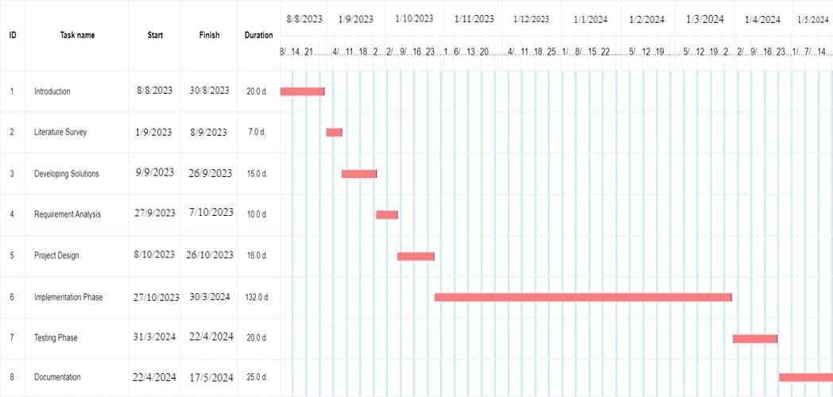**1.5 Project Timeline:**

**Fig. 1 Gantt Chart to monitor Activity and Planning**

A project timeline is a visual list of tasks or activities placed in chronological order, which lets project managers view the entirety of the project plan in one place. A project timeline typically takes the form of a horizontal bar chart, where each task is given a name and a corresponding start and end date. A project timeline provides an in-depth overview of the entire project from start to finish. For our project we have used a Gantt Chart to illustrate the activities done so far and the future activities needed to be done for the project. The timeline is divided into different phases with all the activities allocated to each phase corresponding to the time required. All the phases of our project are mentioned in Fig. 1. In Fig. 1, it has been shown that the implementation phase takes the most amount of time to complete while the Introduction phase, which involves identifying problems and project summary, takes almost the same time to complete as the documentation phase. After the problems are identified in the introduction phase, the requirements specific to the project are identified and then solutions with respect to the problems are discussed and solved. In the testing phase as shown in Fig. 1, we have performed randomness testing to measure the degree of randomness with which our program generates voxels to create the polyhedrons. During this phase, we have also tested our program to detect any remaining bugs that may generate errors while executing the program. Then the project documentation starts to convert our project into a presentable form.

**Chapter 2: Literature Survey**

Non-Fungible Tokens (NFTs) have exploded onto the scene, transforming the digital art and collectibles landscape. These unique digital assets leverage blockchain technology for secure storage and verifiable ownership tracking. NFT marketplaces, built upon this foundation, provide platforms for users to buy, sell, and trade NFTs, fostering a new era of digital ownership. This survey delves into the core technologies underpinning NFT marketplaces, explores their functionalities and benefits, and highlights current research trends shaping their future.

**2.1 Core Technologies:**

1. **Blockchain:** Public ledgers like Ethereum serve as the backbone for NFTs. They offer a secure and immutable platform for storing NFT data, including ownership records, critical for establishing authenticity and provenance. [1]
2. **Smart Contracts:** These self-executing contracts are the engine room of NFT marketplaces. They automate crucial functionalities like NFT creation, transfer of ownership upon sale, and execution of pre-defined rules governing interactions within the marketplace. This eliminates the need for intermediaries, promoting trustless transactions between buyers and sellers. [2]

**2.2 Functionalities of NFT Marketplaces:**

NFT marketplaces offer a comprehensive suite of features to facilitate a seamless user experience:

1. **NFT Creation and Listing:** Creators can upload their digital assets, define ownership rights, and set listing parameters like price or auction details.
2. **NFT Discovery and Purchase:** Buyers leverage search and browse functionalities to discover NFTs, explore details like ownership history and associated metadata, and ultimately purchase them using cryptocurrency.
3. **Auction Mechanisms:** Marketplaces can incorporate auction functionalities, enabling buyers to engage in competitive bidding for high-value or unique NFTs, fostering a dynamic pricing mechanism.
4. **Secure NFT Storage:** The underlying blockchain serves as a secure vault for NFTs, safeguarding them from unauthorized access or modification.
5. **Transparent Transaction History:** Every interaction with an NFT, from creation to sale, is immutably recorded on the blockchain, providing a transparent and verifiable audit trail for ownership and authenticity.

**2.3 Benefits of Blockchain-based NFT Marketplaces:**

The convergence of NFTs and blockchain technology offers a multitude of advantages over traditional marketplaces:

1. **Enhanced Security:** Blockchain's inherent tamper-proof nature significantly reduces the risk of fraud and counterfeiting, as ownership records are publicly verifiable and unalterable.
2. **Transparency and Trust:** All transactions involving NFTs are recorded on the blockchain, fostering trust between buyers and sellers by providing a clear and indisputable record of ownership history.
3. **Decentralization:** By eliminating the need for central authorities, NFT marketplaces empower creators and collectors. Creators can freely distribute their work and retain a level of control over ownership rights, while collectors gain direct access to a wider range of unique digital assets.
4. **Streamlined Efficiency:** Smart contracts automate critical processes within the marketplace, such as NFT creation, transfer, and sale execution. This reduces friction and transaction costs compared to traditional methods.

**2.4 Current Research Trends:**

As the NFT marketplace landscape evolves, several key research areas are shaping its future trajectory:

1. **Scalability Solutions:** The scalability limitations of popular blockchains like Ethereum, which can lead to high transaction fees and slow processing times, are a major hurdle for wider adoption. Researchers are exploring alternative blockchain protocols and scaling solutions like layer-2 networks to address this challenge. [3]
2. **Interoperability:** Enabling seamless transfer of NFTs between marketplaces built on different blockchains is crucial for fostering a more unified ecosystem. Interoperability standards and protocols are being developed to bridge these gaps and allow users greater flexibility in managing their NFT collections.
3. **Expanding NFT Use Cases:** The application of NFTs extends far beyond digital art. Researchers are exploring the potential of NFTs in various sectors, including ticketing systems for events, fractional ownership of digital assets, and representing intellectual property rights for music or creative content.

NFT marketplaces built on blockchain technology offer a secure, transparent, and efficient way to trade unique digital assets. The technology holds immense potential to revolutionize various industries beyond just digital collectibles. As research continues to address scalability challenges and explore new use cases, NFT marketplaces are poised to shape the future of digital ownership and redefine how we interact with and value digital assets.

**Chapter 3: Concepts and Problem Analysis**

**3.1 Concepts:**

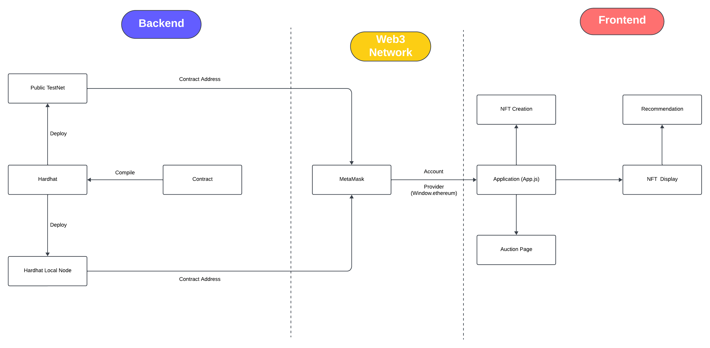

**Fig. 2**

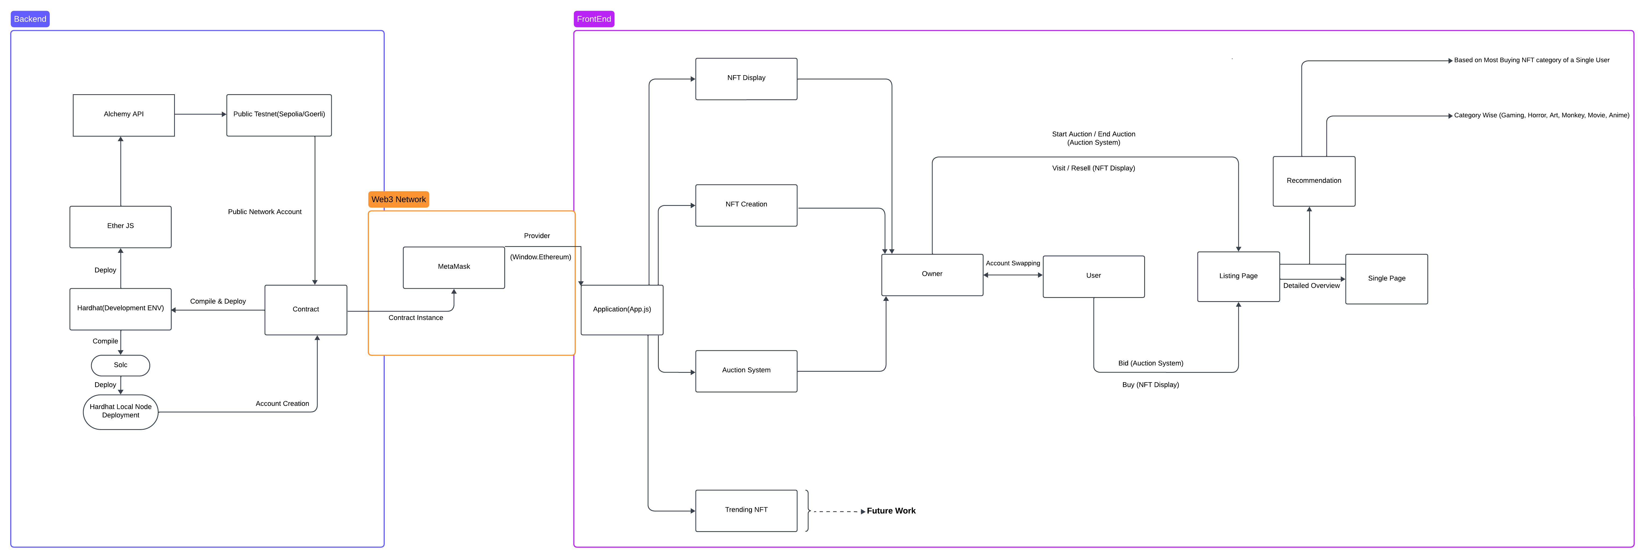

**Fig. 3**

**3.2 Problem Analysis:**

**These problems inspires us to develop our project**

**3.2.1 Preventing Online Document Piracy Using Blockchain:**

Online document piracy is a major issue that plagues creators and publishers. It occurs when unauthorized copies of copyrighted documents are distributed online without permission. This can lead to significant financial losses and undermines the value of intellectual property.

Here's a breakdown of the key aspects of the problem:

* **Unauthenticated Distribution:** Anyone can easily copy and distribute digital documents online, making it difficult to control access and prevent unauthorized sharing.
* **Lack of Transparency:** It's often challenging to track the origin and ownership of a document once it's uploaded online. This makes it difficult to identify and take action against piracy.
* **Difficulty in Copyright Enforcement:** Current copyright enforcement methods can be slow and cumbersome, discouraging creators from pursuing legal action against pirates.

**3.2.2 Validation and Authentication of Digital Asset:**

The problem statement of "Validation and Authentication of Digital Assets" centers around the difficulty of proving ownership and origin of digital content in the online world.

Here's a breakdown of the core issues:

* **Difficulty in Establishing Ownership:** Digital assets, unlike physical ones, can be easily copied and distributed. This makes it challenging to prove who the rightful owner is, especially for intangible assets like intellectual property.
* **Risk of Counterfeits:** The ease of duplication creates opportunities for creating and distributing fake digital assets. This can erode trust in the authenticity of digital content and devalue genuine assets.
* **Lack of Standardized Verification:** Currently, there are various methods for verifying digital assets, but they often lack consistency and can be unreliable. This creates confusion and makes it difficult to trust the validity of digital ownership claims.

These issues can have significant consequences, such as:

* **Loss of Revenue for Creators:** If creators cannot prove ownership of their work, it becomes difficult to enforce copyright and prevent unauthorized use. This can lead to financial losses and disincentivize content creation.
* **Reduced Trust in Digital Markets:** Without reliable authentication, users may be hesitant to purchase digital assets, fearing they might be counterfeit. This can hinder the growth of digital marketplaces.
* **Security Risks:** Fake digital assets can be used for malicious purposes, such as phishing scams or malware distribution.

**These problems we faced during development of our project**

**3.2.3 Problem Statement: Challenges in Cross-Chain Platforms**

Cross-chain platforms aim to bridge the gap between different blockchains, allowing users to transfer assets and interact with applications built on separate blockchain networks. While this technology offers exciting possibilities, there are several significant problems that hinder its widespread adoption:

* **Security Vulnerabilities:** Cross-chain bridges, which facilitate asset transfer, are often complex systems and prime targets for hackers. Exploits in these bridges have led to massive losses of cryptocurrency in recent years.
* **Limited Interoperability:** Different blockchains have varying architectures and protocols. This can make it challenging for cross-chain platforms to achieve seamless communication and data exchange between them.
* **Lack of Standardization:** The cross-chain ecosystem is still evolving, with various approaches and technologies vying for dominance. This lack of standardization creates compatibility issues and hinders user experience.
* **Scalability Challenges:** As the volume of transactions and data on blockchains increases, some cross-chain platforms struggle to maintain efficiency and handle high traffic loads.
* **Limited Asset Support:** Many cross-chain platforms only support a limited number of cryptocurrencies or tokens. This restricts user choice and hinders the overall utility of the platform.

**3.2.4 Problem Statement: Cost and Time Optimization in Blockchain**

Blockchain technology offers a secure and transparent way to record transactions. However, it faces a significant challenge in balancing cost and transaction processing time. Here's a breakdown of the core issues:

**High Transaction Fees:**

* **Limited Scalability:** Blockchains, especially Proof-of-Work (PoW) based ones, can only process a limited number of transactions per second. This leads to congestion during peak usage periods, driving up transaction fees.
* **Competition for Block Space:** Users compete for limited space in each block to include their transactions. This competition can result in bidding wars, pushing fees even higher for users who require faster processing.

**Slow Transaction Processing:**

* **Validation Process:** The consensus mechanism, like PoW, requires significant computational power to validate transactions. This validation process can be time-consuming, leading to delays in transaction confirmation.
* **Block Size Limitations:** Blockchains often have limitations on the size of each block. This restricts the number of transactions that can be included in each block, further slowing down processing times.

**Chapter 4: Design and Methodology**

**Problem Design 1: Designing a Secure Public Network with Blockchain**

Creating a secure public network with blockchain technology presents a unique challenge. While blockchains offer inherent security features like immutability and transparency, achieving true "security" in a public network requires addressing inherent trade-offs.

**Methodology: Designing a Secure Public Network**

Here are some approaches to consider when designing a secure public network with blockchain:

* **Consensus Mechanisms:**
* Proof-of-Stake (PoS) can be more energy-efficient than Proof-of-Work (PoW) and potentially discourage Sybil attacks by requiring a stake in the network. Newer mechanisms like Byzantine Fault Tolerance (BFT) are also being explored for improved scalability and security.
* **Permissioned Public Blockchains:** These hybrid models allow anyone to participate but require identity verification for specific actions (e.g., adding transactions). This balances openness with some control over who can disrupt the network.
* **Zero-Knowledge Proofs (ZKPs):** These cryptographic techniques allow users to prove they possess certain information without revealing the information itself. ZKPs can be used to enhance user privacy while maintaining transaction validity.
* **Reputation Systems:** Implementing a reputation system can incentivize good behavior and disincentivize malicious activity. Users with positive reputations can have more influence on the network.
* **Security Audits and Continuous Monitoring:** Regularly conducting security audits and monitoring the network for suspicious activity are crucial for proactively identifying and addressing vulnerabilities.

**Problem Design 2: Guaranteeing Resource Availability in IPFS**

The InterPlanetary File System (IPFS) boasts a decentralized network for storing and sharing data. However, unlike traditional servers, IPFS doesn't guarantee constant resource availability. Here's why:

* **Decentralized Nature:** IPFS relies on a network of individual nodes, each with varying online status and storage capacity. A resource might be unavailable if the node hosting it is offline or overloaded.
* **Pinning:** For a resource to persist, a node needs to actively "pin" it. Users or pinning services can pin data, but there's no guarantee others will continue pinning indefinitely.

**Methodology: Enhancing Resource Availability in IPFS**

Here are some strategies to improve resource availability in IPFS:

* **Replication:** Store data across multiple nodes. This redundancy increases the chances of finding the resource even if some nodes are unavailable. Tools like IPLD (IPFS Merkle Dag Library) can automate replication strategies.
* **Pinning Services:** Utilize pinning services that commit to storing data for a specific period. These services often have robust infrastructure and ensure higher availability compared to individual nodes.
* **Incentivization:** Create mechanisms that incentivize nodes to pin critical data. This could involve crypto tokens or reputation systems that reward node operators for contributing to network stability.
* **Community-Driven Pinning:** Encourage communities to collaboratively pin important resources. This distributes the responsibility and ensures data relevant to a specific group remains available.
* **File Size Optimization:** Break down large files into smaller chunks and leverage IPFS's content addressing to efficiently retrieve them even if stored across different nodes.

**Problem Design 3: Enhancing Security for MetaMask Transactions**

MetaMask is a popular crypto wallet extension, but as with any online tool, security is paramount when using it for transactions. Here's a breakdown of the key areas to consider:

* **Seed Phrase Compromise:** The seed phrase is the master key to your MetaMask wallet. If compromised, anyone can access and steal your funds.
* **Phishing Attacks:** Deceptive websites or emails can trick you into revealing your seed phrase or private key.
* **Smart Contract Risks:** Interacting with untrusted smart contracts can lead to unintended consequences or loss of funds.
* **Unsecured Connection:** Using MetaMask on an unencrypted Wi-Fi network exposes your transactions to potential interception.

**Methodology: Securing MetaMask Transactions**

Here are some strategies to significantly improve the security of your MetaMask transactions:

* **Seed Phrase Protection:** Never share your seed phrase with anyone, not even MetaMask support. Phishing attempts may impersonate support personnel. Treat any request for your seed phrase as a red flag.
* **Write it down on a piece of paper and store it securely offline** in a fireproof safe or safety deposit box. Consider splitting the phrase into multiple parts stored in separate locations for added protection against physical theft.
* **Consider using a hardware wallet like Ledger or Trezor.** These devices store your seed phrase offline and require physical confirmation for transactions, adding a crucial layer of security. Unlike MetaMask, which stores your private key on your device, hardware wallets provide complete isolation from the online environment.

**Problem Design 4: Building Transparency and User Trust**

In today's digital age, where user data is a valuable commodity, building trust is paramount. Transparency about data practices is key to fostering a positive user experience and establishing strong relationships.

Here's a breakdown of the challenges in achieving transparency and user trust:

* **Complexity of Systems:** Modern applications often collect and utilize data in intricate ways. Users may not fully understand how their data is used, leading to confusion and mistrust.
* **Privacy Concerns:** Users are increasingly wary about how their data is collected, stored, and shared. A lack of transparency can fuel anxieties about potential misuse of personal information.
* **Evolving Regulations:** Data privacy regulations like GDPR and CCPA add a layer of complexity. Keeping users informed about compliance efforts and data governance can be challenging.

**Methodology: Promoting Transparency and User Trust**

Here are some key strategies to build transparency and trust with your users:

* **Clear and Concise Communication:** Use plain language to explain your data collection practices, data usage policies, and user privacy rights. Avoid technical jargon and ensure your communication is clear, concise, and easy to understand for a broad audience.
* **Easily Accessible Information:** Make your privacy policy and other relevant information readily available on your website or application. Don't bury it in hard-to-find locations. Consider creative ways to present this information, such as using infographics or short videos, in addition to a traditional text-based policy document.
* **User Control and Choice:** Empower users to control their data. Provide clear options for users to opt-in or opt-out of data collection and offer them choices regarding how their data is used. This could involve allowing users to choose what data is collected, how long it's stored, and who it's shared with.
* **Data Minimization:** Collect only the data you genuinely need to operate your service effectively. Avoid collecting unnecessary user information that you don't intend to use. This demonstrates respect for user privacy and reduces the potential attack surface for data breaches.
* **Security Measures:** Implement robust security measures to protect user data. Regularly conduct security audits and demonstrate your commitment to safeguarding user information.

**Chapter 5: Sample Codes**

This section includes the coding portions that have been used to do the project. Coding has been done in solidity and react, ether.js have been used to implement the required outputs. Here, we have the complete program to run the Smart Contract.

// SPDX-License-Identifier: MIT

pragma solidity >=0.5.0 <0.9.0;

// import "@openzeppelin/contracts/utils/Counters.sol";

import "@openzeppelin/contracts-upgradeable/token/ERC721/extensions/ERC721URIStorageUpgradeable.sol";

import "@openzeppelin/contracts-upgradeable/proxy/utils/Initializable.sol";

contract NFT_Marketplace is Initializable, ERC721URIStorageUpgradeable {

// using Counters for Counters.Counter;

// Counters.Counter public _tokenIds;

// Counters.Counter public _itemsSold;

// bool public isInitialized = false;

uint public _tokenIds;

uint public _itemsSold;

uint256 private listingPrice;

// uint sample;

address payable owner;

mapping(uint256 => MarketItem) public idMarketItem;

// mapping(uint256 => address[]) public owners;

mapping(address => mapping(string => uint)) public recomendation;

mapping (address => string) private mostNFTS;

mapping (uint => mapping (address => uint)) public bids;

mapping (uint => string) public actualEnd;

uint public bidInc;

struct MarketItem {

uint256 tokenId;

address payable seller;

address payable owner;

uint256 price;

bool sold;

string link;

string about;

bool auctionState;

uint endTime;

address payable highestBiddder;

uint highestPayableBid;

uint bidCount;

}

function initialize(uint listPrice) initializer public {

__ERC721_init("NFT Metaverse Token", "MYNFT");

owner = payable(msg.sender);

listingPrice = listPrice;

// genre = ["gaming", "horror", "monkey", "anime", "art", "movie"];

bidInc = 1000000000000000000;

}

//To show what genre the customer ownes most

function getMaxNFTData(address visitor) public view returns (string memory) {

return mostNFTS[visitor];

}

//To create unique ID for every NFT

function createToken(string memory tokenURI, uint256 price, string memory aboutNFT) external payable returns(uint256){

_tokenIds++;

uint256 newTokenId = _tokenIds;

_mint(msg.sender, newTokenId);

_setTokenURI(newTokenId, tokenURI);

createMarketItem(newTokenId, price, tokenURI, aboutNFT);

return newTokenId;

}

//Create all the market items

function createMarketItem(uint256 tokenId, uint256 price, string memory tokenURI, string memory aboutNFT) private {

require(price > 0 && msg.value == listingPrice && checkIfAboutIsCorrect(string(aboutNFT)));

idMarketItem[tokenId] = MarketItem(

tokenId,

payable(msg.sender),

payable(address(this)),

price,

false,

tokenURI,

aboutNFT,

false,

block.timestamp,

payable(address(0)),

0,

0

);

// owners[tokenId].push(msg.sender);

_transfer(msg.sender, address(this), tokenId);

// emit idMarketItemCreated(tokenId, msg.sender, aboutNFT, address(this), price, false, tokenURI);

}

//Function For Resale Token. To resale the previously bought NFT

function reSellToken(uint256 tokenId, uint256 price) public payable{

require(idMarketItem[tokenId].owner == msg.sender && msg.value == listingPrice);

idMarketItem[tokenId].sold = false;

idMarketItem[tokenId].price = price;

idMarketItem[tokenId].seller = payable(msg.sender);

idMarketItem[tokenId].owner = payable(address(this));

idMarketItem[tokenId].auctionState = false;

_itemsSold--;

recomendation[msg.sender][idMarketItem[tokenId].about] -= 1;

calculateHighestNFT(msg.sender);

_transfer(msg.sender, address(this), tokenId);

}

//Function Create Market Sale. The main buying and saling process

function createMarketSale(uint256 tokenId) public payable{

uint256 price = idMarketItem[tokenId].price;

require(msg.value >= (price + listingPrice));

idMarketItem[tokenId].seller.transfer(msg.value);

buyNFT(tokenId, payable(msg.sender));

}

function buyNFT(uint tokenId, address payable newOwner) public {

// idMarketItem[tokenId].seller.transfer(value);

idMarketItem[tokenId].owner = newOwner;

idMarketItem[tokenId].sold = true;

idMarketItem[tokenId].seller = newOwner;

_itemsSold++;

// owners[tokenId].push(newOwner);

recomendation[newOwner][idMarketItem[tokenId].about] += 1;

calculateHighestNFT(newOwner);

_transfer(address(this), newOwner, tokenId);

}

//Get the unsold NFT Data

function fetchMarketItem() public view returns(MarketItem[] memory) {

uint256 itemCount = _tokenIds;

uint256 unsoldItemCount = _tokenIds - _itemsSold;

uint256 currentIndex = 0;

MarketItem[] memory items = new MarketItem[](unsoldItemCount);

for(uint256 i = 0; i < itemCount; i++){

if(idMarketItem[i + 1].owner == address(this)){

uint256 currenntId = i + 1;

MarketItem storage currentItem = idMarketItem[currenntId];

items[currentIndex] = currentItem;

currentIndex += 1;

}

}

return items;

}

//Purchase Item

function fetchMyNFT() public view returns(MarketItem[] memory) {

uint256 totalCount = _tokenIds;

uint256 itemCount = 0;

uint256 currentIndex = 0;

for(uint256 i = 0; i < totalCount; i++){

if(idMarketItem[i + 1].owner == msg.sender){

itemCount += 1;

}

}

MarketItem[] memory items = new MarketItem[](itemCount);

for(uint256 i = 0; i < totalCount; i++){

if(idMarketItem[i + 1].owner == msg.sender){

uint256 currentId = i + 1;

MarketItem storage currentItem = idMarketItem[currentId];

items[currentIndex] = currentItem;

currentIndex += 1;

}

}

return items;

}

//This function calculates the type of NFT that a customer ownes most

function calculateHighestNFT(address visitor) internal{

string[6] memory tempGenre = ["gaming", "horror", "monkey", "anime", "art", "movie"];

uint max = 0;

string memory maxGenre;

for(uint i = 0; i < tempGenre.length; i++){

uint temp = recomendation[visitor][tempGenre[i]];

if(temp > max){

max = temp;

maxGenre = tempGenre[i];

}

}

mostNFTS[visitor] = maxGenre;

}

//This function checks if the customer gives the name of the genre correct

function checkIfAboutIsCorrect(string memory aboutNFT) private pure returns(bool){

string[6] memory tempGenre = ["gaming", "horror", "monkey", "anime", "art", "movie"];

for(uint i = 0; i < tempGenre.length; i++){

if(keccak256(abi.encodePacked(aboutNFT)) == keccak256(abi.encodePacked(tempGenre[i]))){

return true;

}

}

return false;

}

//This function is used to end auction for a particular NFT

function EndAuc(uint tokenId) public{

address payable hb = idMarketItem[tokenId].highestBiddder;

address payable s = idMarketItem[tokenId].seller;

uint hpb = idMarketItem[tokenId].highestPayableBid;

address ms = msg.sender;

uint bc = idMarketItem[tokenId].bidCount;

require(block.timestamp > idMarketItem[tokenId].endTime && payable(msg.sender) != hb);

if(hb != address(0)){

uint value;

if(payable(ms) == s){

if(bids[tokenId][hb] == hpb){

bids[tokenId][hb]=0;

s.transfer(hpb - 1500000000000000);

buyNFT(tokenId, hb);

}else{

value = (bids[tokenId][hb] - hpb) - 1500000000000000;

bids[tokenId][hb]=0;

s.transfer(hpb);

hb.transfer(value);

buyNFT(tokenId, hb);

}

}else if(bids[tokenId][ms] != 0){

value = bids[tokenId][ms];

bids[tokenId][ms]=0;

payable(ms).transfer(value);

}

bc--;

}

if(bc == 0){

idMarketItem[tokenId].auctionState = false;

}

}

//To calculate the minimum of 2 numbers

function min(uint a, uint b) pure private returns (uint){

if(a<=b){

return a;

}

return b;

}

//This function is used to start auction for a particular NFT

function startAuction(uint tokenId, string memory endTime) public {

require(idMarketItem[tokenId].seller == msg.sender && !idMarketItem[tokenId].sold);

idMarketItem[tokenId].auctionState = true;

idMarketItem[tokenId].endTime = block.timestamp + 120;

actualEnd[tokenId] = endTime;

}

//This function is used to place a bid for a particular NFT

function placeBid(uint tokenId) public payable {

uint currentbid = bids[tokenId][msg.sender] + msg.value;

require(currentbid > idMarketItem[tokenId].highestPayableBid && block.timestamp <= idMarketItem[tokenId].endTime && msg.sender != idMarketItem[tokenId].seller && msg.value >= 1000000000000000000);

// require(block.timestamp <= idMarketItem[tokenId].endTime, "Auction ended");

// require(msg.sender != idMarketItem[tokenId].seller, "You are the owner");

// require(msg.value >= 1000000000000000000, "Pay More");

if(bids[tokenId][msg.sender] == 0){

// bidsAddresses[tokenId][idMarketItem[tokenId].bidCount] = msg.sender;

idMarketItem[tokenId].bidCount++;

}

bids[tokenId][msg.sender] = currentbid;

if(currentbid < bids[tokenId][idMarketItem[tokenId].highestBiddder]){

idMarketItem[tokenId].highestPayableBid = min(currentbid + bidInc, bids[tokenId][idMarketItem[tokenId].highestBiddder]);

}else{

idMarketItem[tokenId].highestPayableBid = min(currentbid,bids[tokenId][idMarketItem[tokenId].highestBiddder]+bidInc);

idMarketItem[tokenId].highestBiddder = payable(msg.sender);

}

}

}

**Chapter 6: Testing and Results**

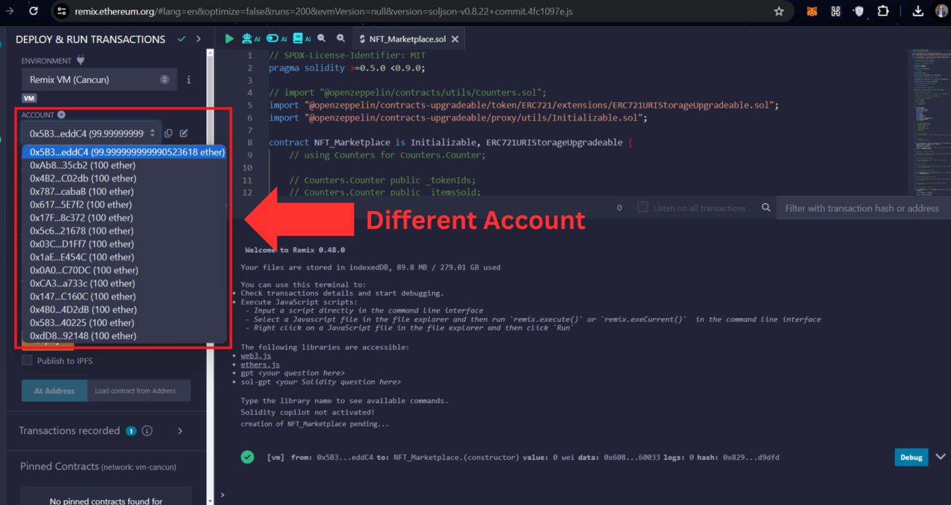**6.1 Unit Testing / Black Box Testing:**

**Fig. 4**

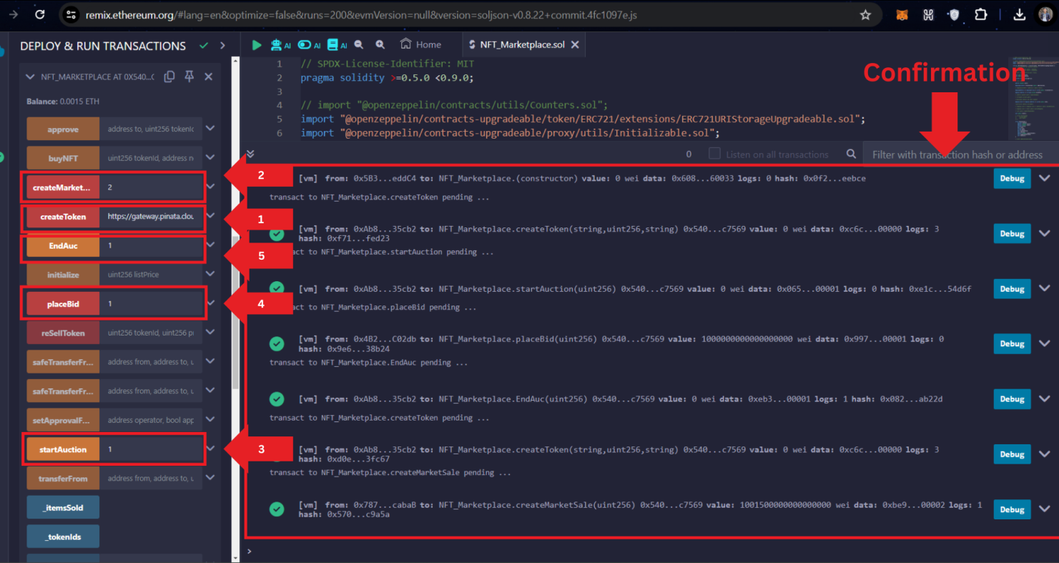

**Fig. 5**

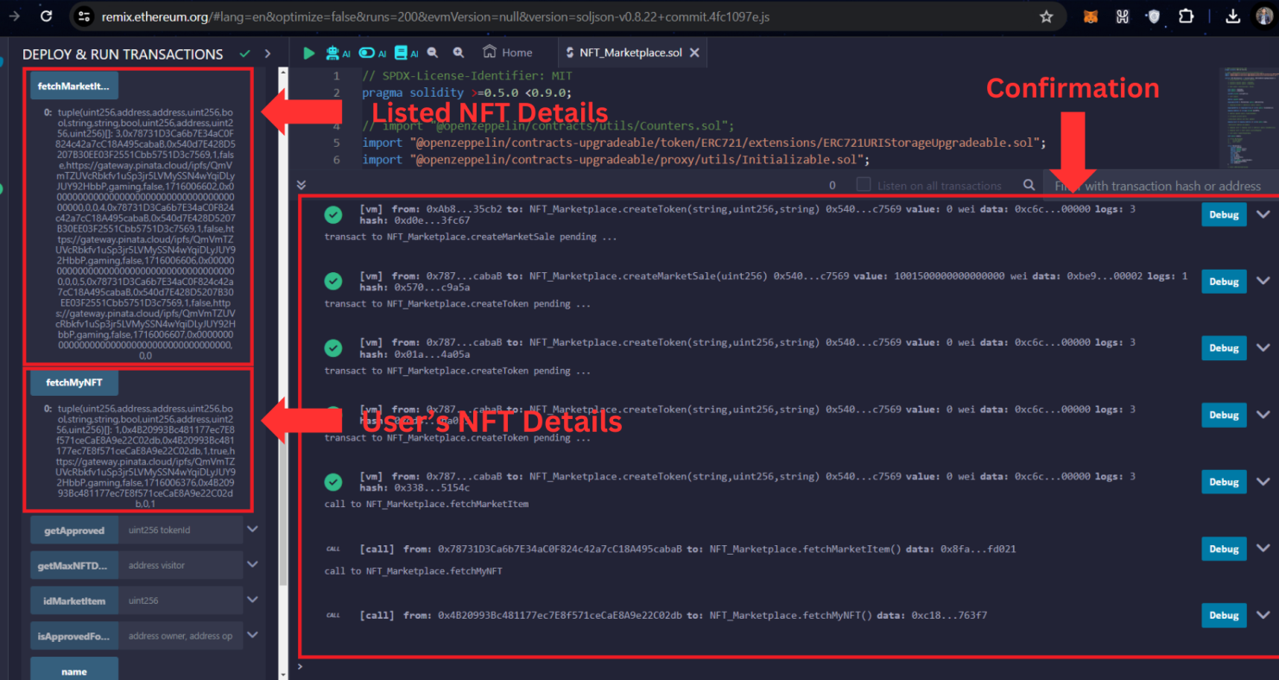

**Fig. 6**

**Testing an NFT Marketplace Smart Contract in Remix Local Environment**

**I. Setting Up the Environment**

* **Remix IDE:** Access Remix online at <https://remix.ethereum.org/>.
* **Solidity Contract:** Create a new Solidity file (.sol) in Remix and paste your NFT Marketplace smart contract code.
* **Compilation:** Click the Solidity compiler icon (gear symbol) and ensure compilation is successful. This checks for syntax errors and validates your code against Solidity standards.

**II. Testing Functions**

**1. createMarketItem (Function Name May Vary)**

* **Description:** This function allows users to create a new NFT listing for sale in the marketplace. It typically includes arguments for:
  + tokenId: Unique identifier of the NFT being listed.
  + startingPrice: Initial asking price for the NFT.
  + duration (optional): Optional timeframe for the listing (e.g., auction duration).
* **Testing Process:**
  + Use the "Deploy" tab in Remix. Select the appropriate environment (usually the JavaScript VM).
  + Connect a test account (provided by Remix) with sufficient test Ether for transaction fees.
  + Provide values for tokenId, startingPrice, and duration (if applicable).
  + Simulate the transaction by clicking "createMarketItem."
* **Expected Outcome:**
  + The transaction should be successful, creating a new market item entry for the NFT with the provided details.
  + Verify the entry's existence and correctness in the contract's storage using the "Deployed Contracts" tab.

**2. startAuction (Optional, if Auction Functionality Exists)**

* **Description:** This function initiates an auction for a listed NFT, allowing users to compete with bids. It might include arguments for:
  + marketItemId: ID of the existing market item to start an auction for.
  + startingPrice: Minimum starting bid for the auction.
  + duration (optional): Optional duration for the auction to run.
* **Testing Process:**
  + Ensure a market item with the corresponding marketItemId exists.
  + Provide values for marketItemId, startingPrice, and duration (if applicable).
  + Simulate the transaction by clicking "startAuction."
* **Expected Outcome:**
  + The transaction should successfully transition the market item into an auction state.
  + Verify the auction details (starting price, duration, current highest bid, etc.) in the contract's storage.

**3. placeBid (Optional, if Auction Functionality Exists)**

* **Description:** This function allows users to submit bids on an ongoing auction for an NFT. It might take arguments for:
  + marketItemId: ID of the market item associated with the auction.
  + bidAmount: The amount the user is offering for the NFT.
* **Testing Process:**
  + Make sure an active auction is ongoing for the desired marketItemId.
  + Provide a bidAmount that exceeds the current highest bid (if any).
  + Simulate the transaction by clicking "placeBid."
* **Expected Outcome:**
  + The transaction should be successful, updating the highest bid in the auction with the user's bid.
  + Verify that the contract's storage reflects the updated highest bid.
  + Consider testing edge cases, like bidding lower than the current highest bid or attempting a bid after the auction ends.

**4. endAuction (Optional, if Auction Functionality Exists)**

* **Description:** This function concludes the auction and transfers the NFT to the highest bidder. It might take an argument for:
  + marketItemId: ID of the market item associated with the auction to be finalized.
* **Testing Process:**
  + Ensure an ongoing auction exists for the marketItemId.
  + Simulate the transaction by clicking "endAuction."
* **Expected Outcome:**
  + The transaction should successfully transfer the NFT to the highest bidder's account.
  + Verify that the ownership of the NFT, as stored in the contract or an external token standard (e.g., ERC-721), is updated.
  + Consider testing edge cases, like ending an auction with no bids or if the highest bidder withdraws their bid before finalization.

**5. createMarketSell (Function Name May Vary)**

* **Description (Alternative to startAuction):** This function allows listing an NFT for a fixed price immediate sale in the marketplace. It might include arguments for:
  + tokenId: Unique identifier of the NFT being listed.
  + sellingPrice: Fixed price at which the NFT is offered for sale.

**6.2 Integration Testing / White Box Testing:**

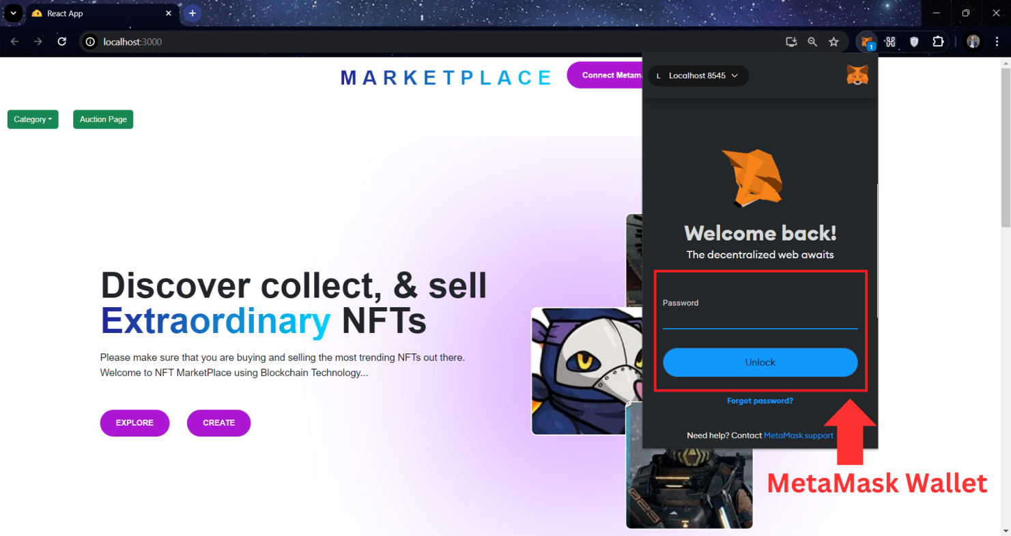

**Fig. 7**

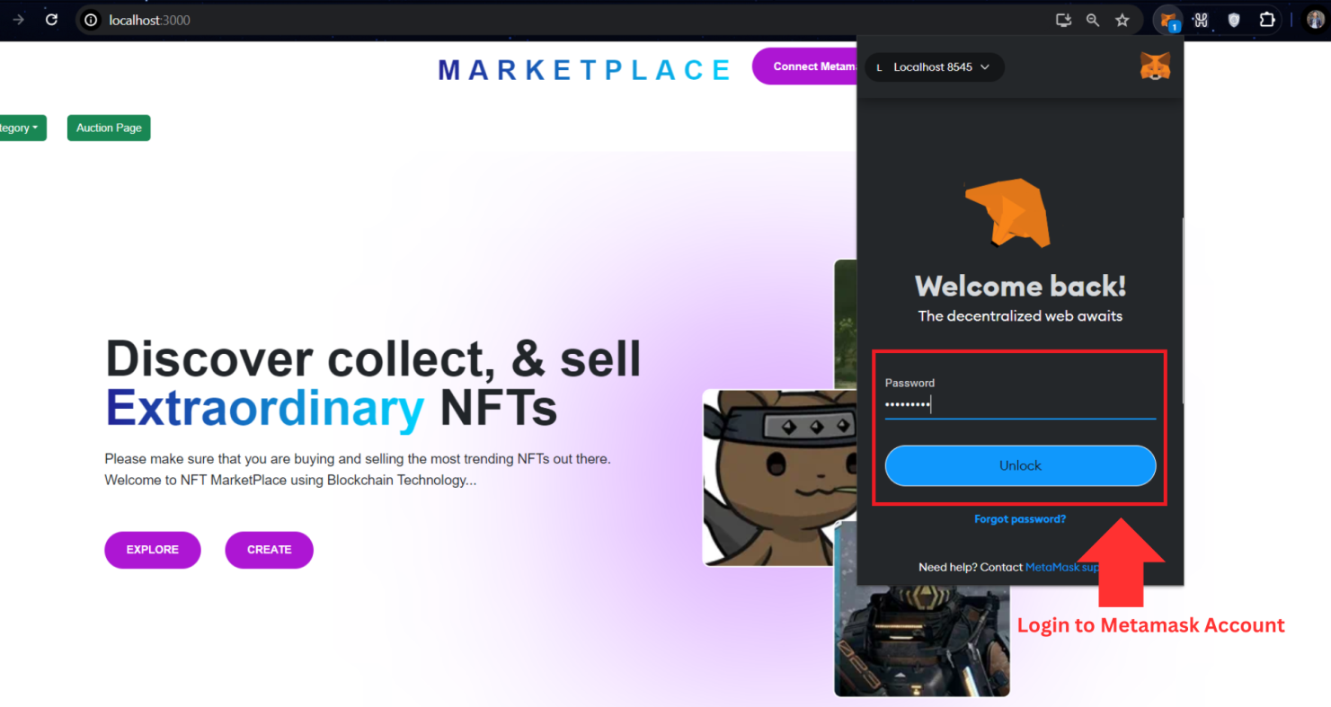

**Fig. 8**

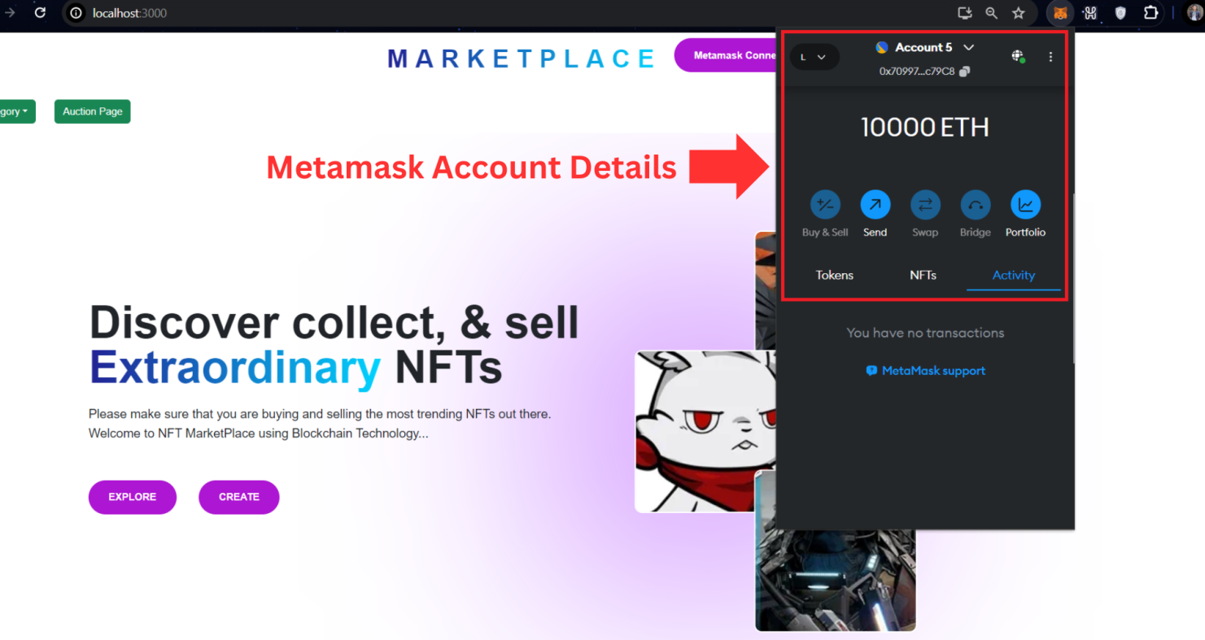

**Fig. 9**

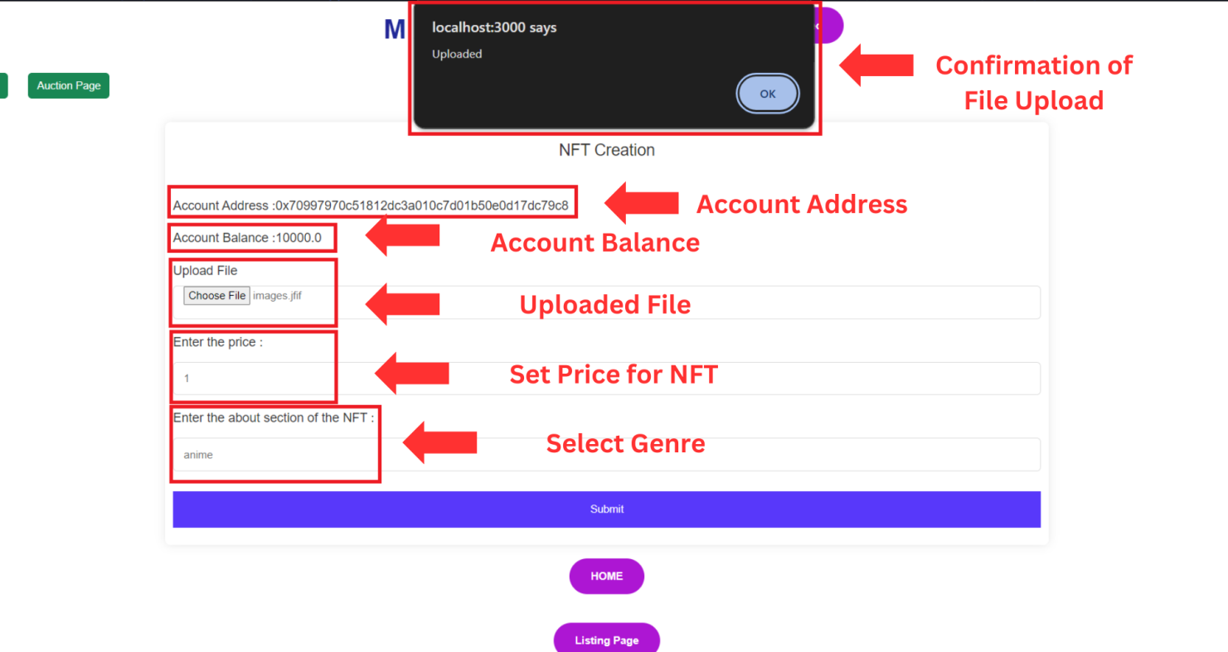

**Fig. 10**

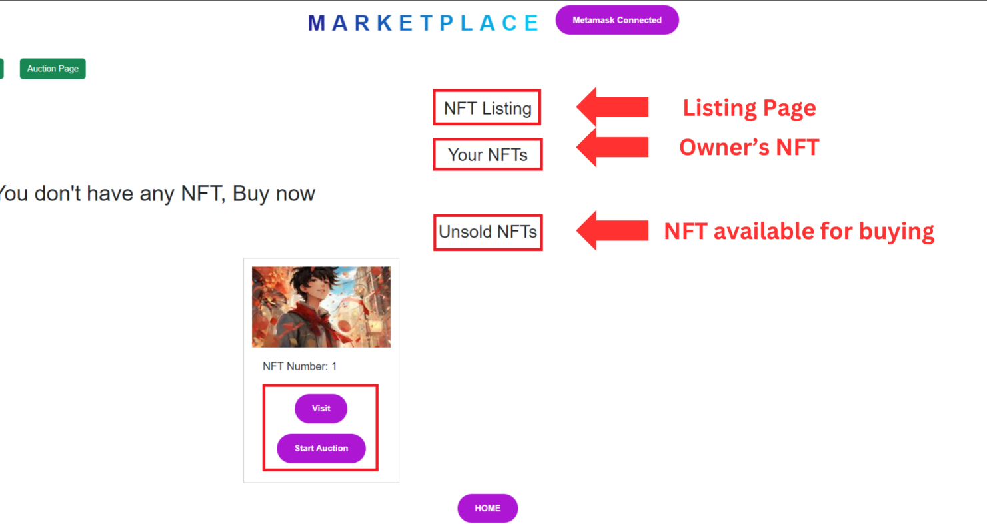

**Fig. 11**

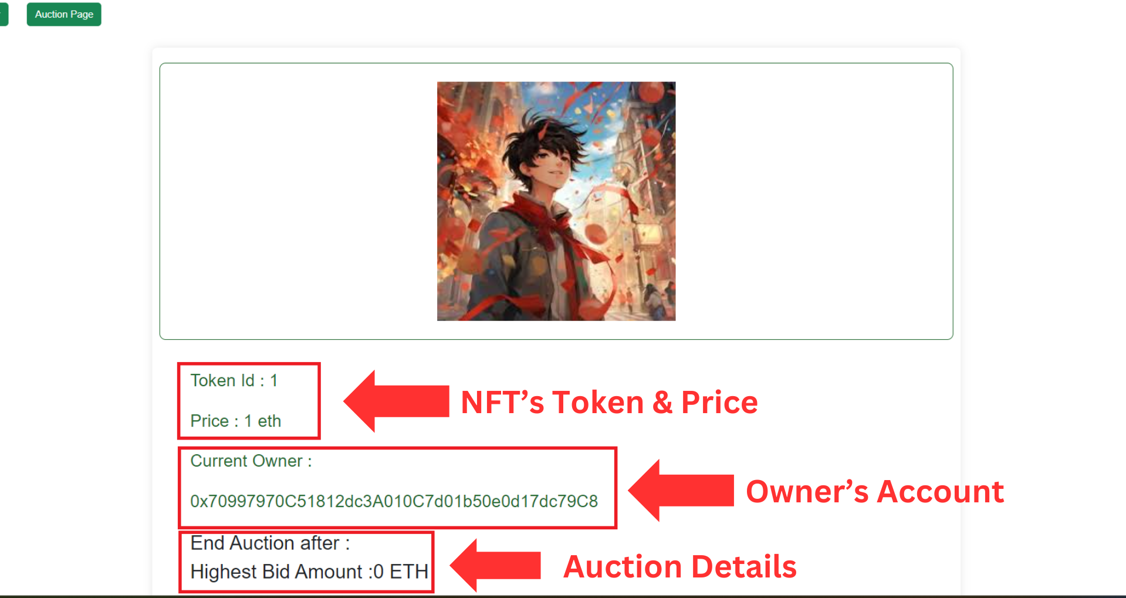

**Fig. 12**

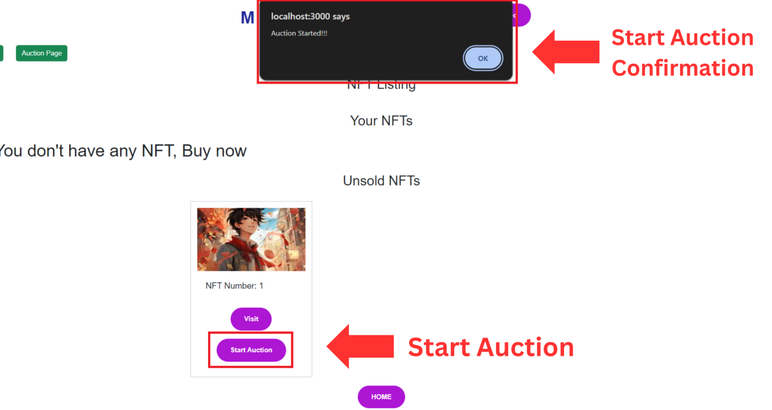

**Fig. 13**

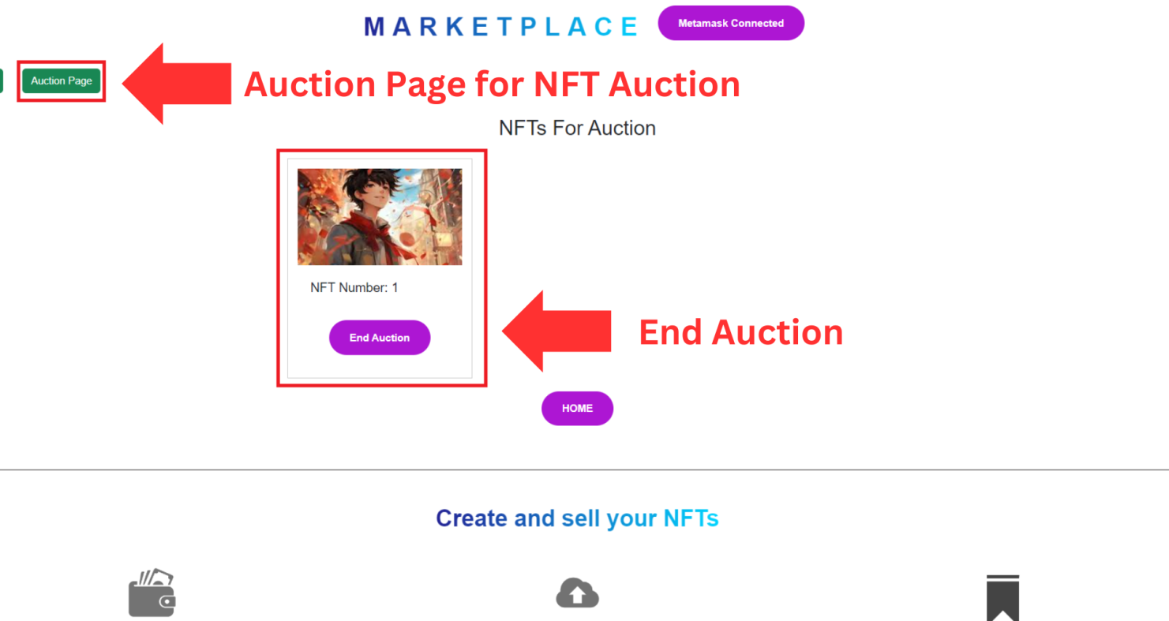

**Fig. 14**

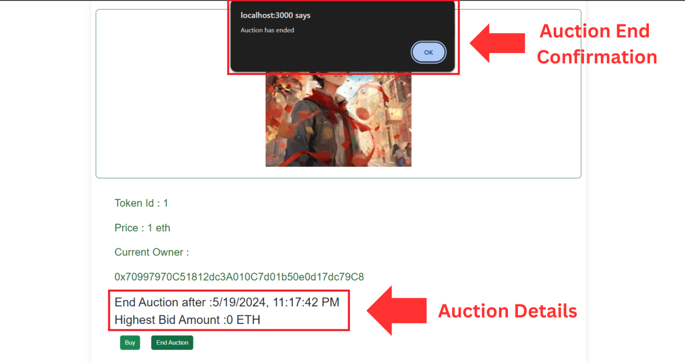

**Fig. 15**

**NFT Marketplace Integration Testing with MetaMask and Hardhat Localhost**

**Testing Scope:** This test session focuses on integration testing of the NFT Marketplace user interface (frontend) with the functionalities implemented by the smart contract deployed on a Hardhat localhost environment. The MetaMask browser extension will be used to simulate wallet interactions for buying, selling, and auctioning NFTs.

**Functionalities Tested:**

1. **Create Token:**
   * Test uploading a digital asset (image, video, audio, etc.).
   * Verify that metadata (name, description, etc.) can be entered for the NFT.
   * Check successful minting of the NFT and confirmation in the user's wallet.
2. **Listing Page:**
   * Navigate to the listings page and verify that all created NFTs are displayed.
   * Check that the listed NFTs display core information like image preview, title, and creator.
3. **Single NFT Details Page:**
   * Select a specific NFT from the listings page and access its details page.
   * Verify that detailed information about the NFT is displayed, including complete metadata, ownership history, and current price (if for sale).
4. **Buying Option (Fixed Price):**
   * If the NFT has a fixed price, initiate a purchase using the "Buy" button.
   * Simulate the purchase using MetaMask by approving the transaction and paying the required fees.
   * Verify successful transfer of the NFT to the buyer's wallet and update of ownership information on the platform.
5. **Recommendation System (Optional):**
   * Explore the recommendations section, if available, and see if it suggests similar NFTs based on user's creations or browsing history.
   * Verify that the recommendations are relevant and provide a good user discovery experience.
6. **Start Auction:**
   * If the option to create an auction exists, initiate the auction for a chosen NFT.
   * Set the starting price, duration, and any additional auction parameters.
   * Simulate the auction creation using MetaMask, approving the transaction for interacting with the contract.
   * Verify that the NFT is listed for auction and the auction details are displayed accurately.
7. **Place Bid (Auction):**
   * Navigate to the ongoing auction page for a specific NFT.
   * Simulate placing a bid using MetaMask, approving the transaction for the bid amount.
   * Verify that the bid is reflected in the auction details page and the highest bidder is updated accordingly.
8. **End Auction:**
   * If there's a functionality to manually end the auction before the set duration, try initiating it (if applicable to the chosen auction).
   * Simulate the transaction using MetaMask and verify successful transfer of the NFT to the highest bidder and completion of the auction.
9. **Auction Page:**
   * Visit the auction page for various NFTs and verify that auction details like current bid, time remaining, and highest bidder are displayed accurately.
   * Check if countdown timers for ongoing auctions function properly.

**Chapter 7: Conclusion and Future Work**

In conclusion, continual advancements in NFT technology pave the way for broader adoption and exploration, driving future innovations in digital ownership and decentralized ecosystems.

**7.1 Conclusion:**

In conclusion, the development of a decentralized NFT marketplace using blockchain technology holds immense potential in revolutionizing digital ownership, empowering creators, and facilitating transparent asset trading. Leveraging blockchain protocols like Ethereum or Binance Smart Chain alongside smart contracts and NFT standards, this project aims to create a secure and user-friendly platform for minting, buying, and selling NFTs. The emphasis on community governance, regulatory compliance, and environmental sustainability underscores the commitment to fostering a trustworthy and inclusive ecosystem. Challenges such as scalability, user experience enhancement, regulatory uncertainties, and interoperability were identified and addressed within the project scope. Despite these challenges, the project lays the groundwork for a transformative marketplace, aligning with the evolving landscape of digital assets and blockchain technology.

**7.2 Future Work:**

Continued advancements and enhancements in the decentralized NFT marketplace can be pursued in several directions:

* **Scalability Solutions**: Exploring and implementing layer 2 solutions or transitioning to more scalable blockchain networks to mitigate congestion and reduce transaction costs.
* **Enhanced User Experience**: Iterative improvements to the user interface, educational resources, and onboarding processes to cater to a broader user base, including non-tech-savvy individuals.
* **Regulatory Adaptation**: Continual monitoring and adaptation to evolving regulatory landscapes, ensuring compliance with emerging laws and standards related to digital assets and NFTs.
* **Interoperability Initiatives**: Collaboration with other blockchain networks and projects to establish improved standards for cross-chain interoperability, enabling seamless asset transfers.
* **Environmental Sustainability**: Shifting towards greener consensus mechanisms or contributing to sustainability initiatives within blockchain ecosystems to reduce energy consumption.
* **Advanced Security Measures**: Regular security audits, research on new security practices, and prompt response to emerging threats to fortify the platform against potential vulnerabilities.
* **Diversification and Innovation**: Encouraging the tokenization of diverse assets beyond art or collectibles, exploring new use cases, and fostering innovation within the NFT space.

**Reference / Bibliography**

[1] Gorkhali, A., Li, L. and Shrestha, A., 2020. Blockchain: A literature review. *Journal of Management Analytics*, *7*(3), pp.321-343.

[2] Zheng, Z., Xie, S., Dai, H., Chen, X., & Wang, H. (2017, June). An overview of blockchain technology: Architecture, consensus, and future trends. In 2017 IEEE international congress on big data (BigData congress) (pp. 557-564). Ieee.

[3] Efanov, D., & Roschin, P. (2018). The all-pervasiveness of the blockchain technology. Procedia computer science, 123, 116-121.

[4] Tikhomirov, S. (2018). Ethereum: state of knowledge and research perspectives. In Foundations and Practice of Security: 10th International Symposium, FPS 2017, Nancy, France, October 23-25, 2017, Revised Selected Papers 10 (pp. 206-221). Springer International Publishing.

[5] Chen, T., Li, Z., Zhu, Y., Chen, J., Luo, X., Lui, J. C. S., ... & Zhang, X. (2020). Understanding ethereum via graph analysis. ACM Transactions on Internet Technology (TOIT), 20(2), 1-32.  
  
[6] Sparks, D. Larry, Stephen W. Scheff, Huaichen Liu, Teresa M. Landers, Carolyn M. Coyne, and John C. Hunsaker III. "Increased incidence of neurofibrillary tangles (NFT) in non-demented individuals with hypertension." *Journal of the neurological sciences* 131, no. 2 (1995): 162-169.

[7] Pirker, D., Fischer, T., Witschnig, H., & Steger, C. (2021, January). velink-a blockchain- based shared mobility platform for private and commercial vehicles utilizing erc-721 tokens. In 2021 IEEE 5th International Conference on Cryptography, Security and Privacy (CSP) (pp. 62- 67). IEEE

[8] Bella, G., Cantone, D., Longo, C., Nicolosi Asmundo, M., & Santamaria, D. F. (2021, September). Blockchains through ontologies: the case study of the Ethereum ERC721 standard in OASIS. In International Symposium on Intelligent and Distributed Computing (pp. 249-259). Cham: Springer International Publishing.